Anniversary

This is what sunshine tastes like: ‘MorgenStund’ becomes ‘SonnenStund’

20 years of alkaline pleasure: in November, P. Jentschura is celebrating the anniversary of its popular millet and buckwheat porridge with a new name. The tried-and-tested recipe and quality remain unchanged.

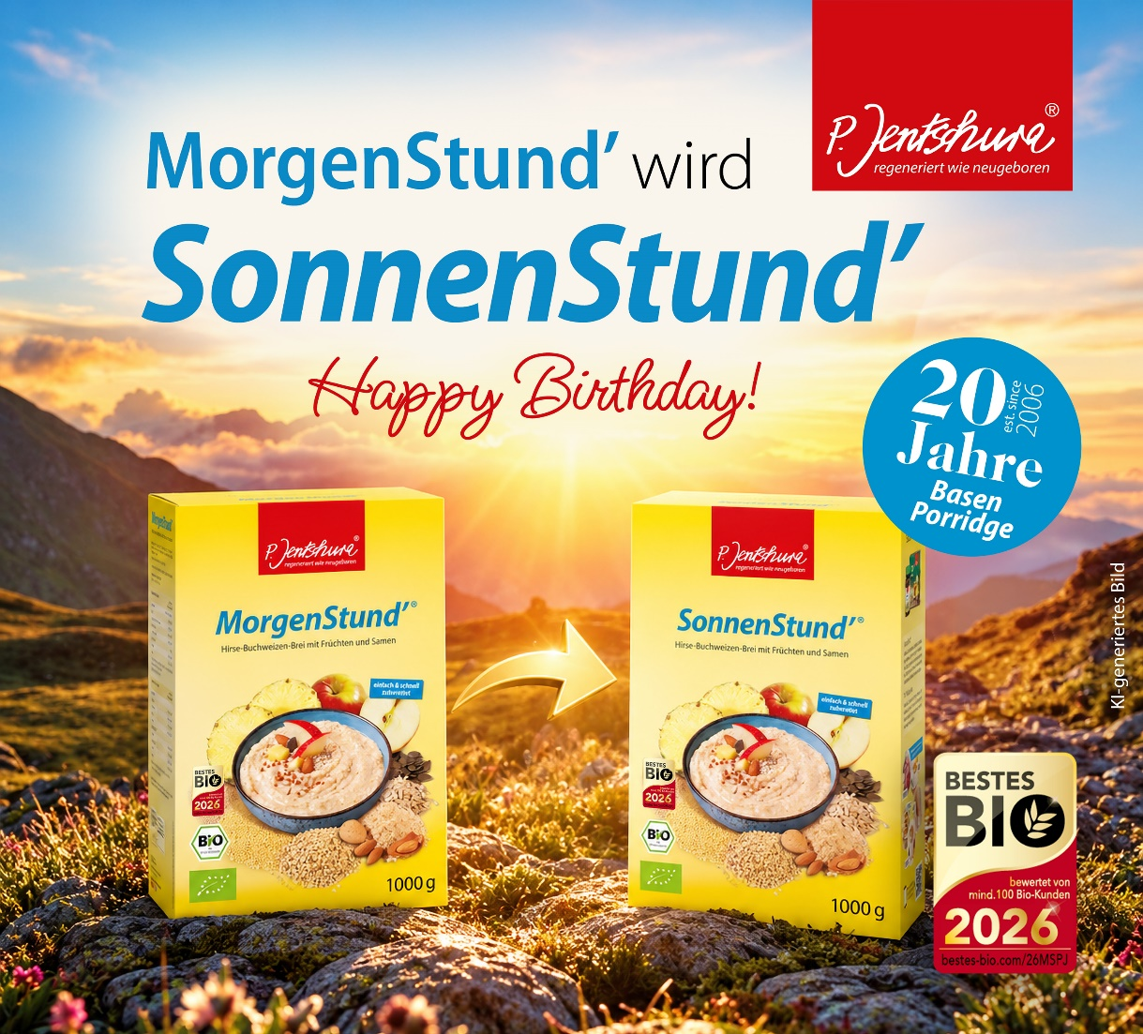
Caption: MorgenStund’ becomes SonnenStund’.

Münster, 05.11.2026 A new name that leaves you wanting more:
P. Jentschura is celebrating the 20th anniversary of its popular millet and buckwheat porridge with a sunny new look. From November 2026, ‘MorgenStund’ will become ‘SonnenStund’. What remains are the tried-and-tested recipe, the high organic quality and the familiar taste. The new name sums up what has set this versatile product apart for two decades: a treat that brings joy not just in the morning, but at any time of day.

A New Name. 20 Years of Great Taste

Since 2006, P. Jentschura’s gluten-free millet and buckwheat porridge has been delighting people with its flavour and versatility. Whether as a warm breakfast, a fruity smoothie, a dessert or an ingredient in homemade waffles, cakes and biscuits – it has long since become much more than a classic breakfast dish and provides great tas at any time of day.

To mark its 20th anniversary, the popular organic porridge is therefore being given a name that does justice to this versatility: SonnenStund’. The new name stands for moments of joy regardless of the time of day and brings sunshine to your diet.

Tried-and-tested quality, new name

There’s good news for everyone who knows and loves MorgenStund’: the recipe and quality remain the same. The characteristic sunny-yellow packaging is also being retained. Furthermore, SonnenStund’ can continue to boast the ‘Bestes Bio’ award.

Peter Jentschura, the company’s founder and pioneer of alkaline nutrition, congratulates his popular invention:

“It was 2006. Nobody believed in a warm breakfast porridge. But what happened was the renaissance of porridge. Now our alkaline porridge is already celebrating its 20th anniversary and is being given a new name: SonnenStund’. The recipe and quality, as well as the cheerful yellow packaging, remain exactly the same. The product is identical. The only change is that ‘Morgen’ becomes ‘Sonnen’! For two decades now,
P. Jentschura’s millet and buckwheat porridge has been a reliable companion for millions of people throughout the day. For many, it’s more than just breakfast – it’s a nutrient-rich highlight. Prepared in a variety of ways – as porridge, a smoothie or a dessert, or in the form of waffles, cakes or biscuits – it brings sunshine into your life!”

More news from the world of alkaline living by P. Jentschura

And there’s another reason to celebrate: P. Jentschura is launching its new website. At https://www.p-jentschura.com, anyone interested can immerse themselves in the diverse world of alkaline living, discover inspiring ideas for everyday life and learn interesting facts about an alkaline, wholefood diet and alkaline personal care. Fascinating insights and the latest news from the world of the alkaline pioneer invite you to drop by time and again.

- End –

P. Jentschura and Jentschura International GmbH

Jentschura International GmbH, with its umbrella brand P. Jentschura, is a leading manufacturer of alkaline body care products and organic foods.

Around 100 employees work for the company, which was founded in 1993 and is based in Münster, Westphalia in north-western Germany. The alkaline pioneer exports its products and concepts for beauty, health and vitality to more than 20 countries. The entire core range is manufactured in-house.
P. Jentschura is a partner of Europe's most spectacular road bike and mountain bike stage races, the TOUR and BIKE Transalp.

Further information about P. Jentschura and Jentschura International GmbH can be found at the following link:

https://www.p-jentschura.com/en/

Peter Jentschura Publishing House (Verlag Peter Jentschura)

Peter Jentschura Publishing House (founded in 1982) is based in Münster/Germany and publishes books and magazines on healthy living. The published books and brochures focus on the topics of purification, deacidification and detoxification, as well as the “three-step purification process”, a three-stage method developed by Peter Jentschura to rid the body of harmful substances and to counteract or prevent lifestyle diseases.

Guidebooks on nutrition and personal hygiene, mental health and personal development round off the programme. The book ‘Health by Purification’ is considered one of the fundamental works on the subject of acid-base balance.

With the magazine series ‘Unser Wissen’ (Our Knowledge), the publisher Peter Jentschura addresses various topics such as ‘Healthy Ageing’ or ‘Metabolic Pitfalls in Women's Lives’ and many others.

Available at www.verlag-jentschura.de

Contact
Jentschura International GmbH
Otto-Hahn-Straße 22-26
D-48161 Münster
www.p-jentschura.com

Press contact:
Christine Elkemann
Senior Communications Manager

Tel: +49 (0) 25 34 - 97 44 – 171
Fax: +49 (0) 25 34 - 97 44 - 4172
E-Mail: celkemann@p-jentschura.com



